|  |  |
| --- | --- |
| Name : | Navya Siddhu |
| UID : | 23BCS11585 |
| Section : | 622 (B) |

Experiment 4.II

PART A:

CREATE TABLE StudentEnrollments (

enrollment_id INT AUTO_INCREMENT PRIMARY KEY,

student_name VARCHAR(100),

course_id VARCHAR(10),

enrollment_date DATE,

UNIQUE (student_name, course_id) -- prevents duplicate enrollment

);

INSERT INTO StudentEnrollments (student_name, course_id, enrollment_date)

VALUES ('Ashish', 'CSE101', '2024-07-01');

START TRANSACTION;

INSERT INTO StudentEnrollments (student_name, course_id, enrollment_date)

VALUES ('Ashish', 'CSE101', '2024-07-01');

COMMIT;

START TRANSACTION;

INSERT INTO StudentEnrollments (student_name, course_id, enrollment_date)

VALUES ('Ashish', 'CSE101', '2024-07-01'); -- ERROR: Duplicate entry

COMMIT;

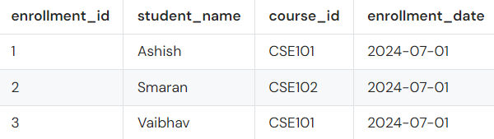

PART B:

START TRANSACTION;

SELECT * FROM StudentEnrollments

WHERE student_name = 'Ashish' AND course_id = 'CSE101'

FOR UPDATE;

START TRANSACTION;

UPDATE StudentEnrollments

SET enrollment_date = '2024-07-15'

WHERE student_name = 'Ashish' AND course_id = 'CSE101';

PART C:

START TRANSACTION;

UPDATE StudentEnrollments

SET enrollment_date = '2024-08-01'

WHERE student_name = 'Ashish' AND course_id = 'CSE101';

START TRANSACTION;

UPDATE StudentEnrollments

SET enrollment_date = '2024-09-01'

WHERE student_name = 'Ashish' AND course_id = 'CSE101';

COMMIT; 